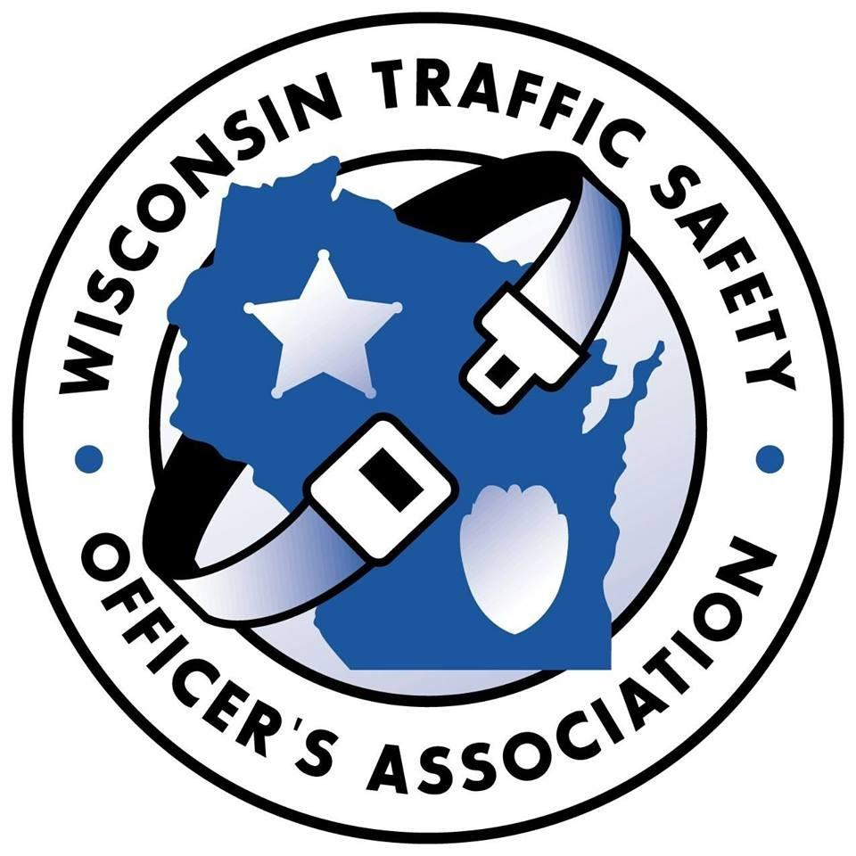
WISCONSIN TRAFFIC SAFETY OFFICER’S ASSOCIATION
February 23rd, 24th, and 25th, 2026
Chula Vista Resort
Wisconsin Dells, WI

Lodging Reservations
Call (608) 254-8366, and then reference booking ID # L03688 and group name “Traffic Safety Officers”

CONFERENCE REGISTRATION FORM

Name:

Rank or Title: Agency:

DRE: Yes No

Address:

City & Zip:

Phone:

Email:

Tuesday Plated Lunch Choice: Beef Tips Cabernet Sweet Chili Pork Loin

Agency billing contact name:
Agency billing contact phone:
Agency billing contact email:

*Registration Fee is $250.00 which includes most meals.
**Registration forms can be emailed or mailed to the below address.
****If you pay via PAYPAL, the registration fee is $260.00 ($10.00 service fee).

Please select payment method

Bill agency If you choose this method, please add the name and email address of the
person responsible for payment. Invoices will be emailed to this person.
Name: Email:

Check Enclosed Payable to WI Traffic Safety Officer’s Association

Mail or email completed form to:
Registration Coordinator
PO Box 22​
Cedarburg, WI 53012
WITrafficSafety@gmail.com

