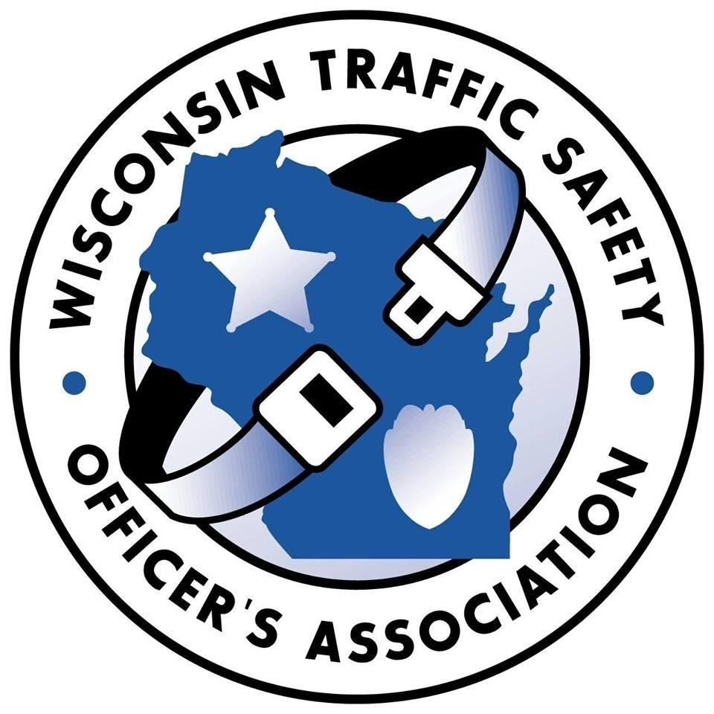
WISCONSIN TRAFFIC SAFETY OFFICER’S ASSOCIATION
February 22nd, 23rd, and 24th, 2027
Chula Vista Resort Wisconsin Dells, WI

Lodging Reservations
Dial the Chula Vista Resort phone number 855-685-9303 and then reference booking ID # L03690 and group name “Traffic Safety Officers”
- or -
Go to Chula Vista page https://secure.chulavistaresort.com/irmng/#/
For state rates: In the upper right click "Group Login"
Enter code: TRAFFIC

CONFERENCE REGISTRATION FORM

Name:

Rank or Title: Agency:

DRE: Yes ☐ No ☐

Address:

City & Zip:

Phone:

Email:

Tuesday Plated Lunch Choice: ☐ Beef Meal ☐ Chicken Meal

Agency billing contact name:
Agency billing contact phone:
Agency billing contact email:

*Registration Fee is $250.00 which includes most meals.
**Registration forms can be emailed or mailed to the below address.
****If you pay via PAYPAL, the registration fee is $260.00 ($10.00 service fee).

Please select payment method

Bill agency ☐ If you choose this method, please add the name and email address of the
person responsible for payment. Invoices will be emailed to this person.
Name: Email:

Check Enclosed ☐ Payable to WI Traffic Safety Officer’s Association

Mail or email completed form to:
Registration Coordinator
PO Box 22​
Cedarburg, WI 53012
WITrafficSafety@gmail.com

