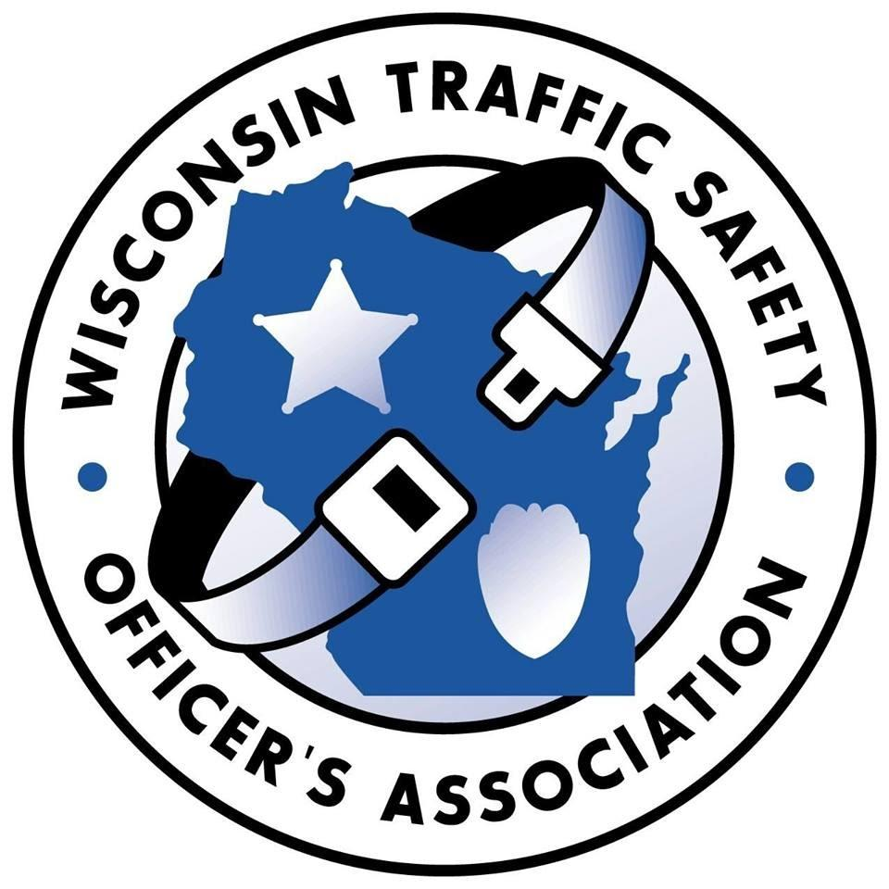
WISCONSIN TRAFFIC SAFETY OFFICER’S ASSOCIATION

Annual Training Conference for Traffic Safety Professionals
Monday-Tuesday-Wednesday, February 26, February 27, February 28, 2024
Radisson Hotel and Conference Center
Fond du Lac, WI

Lodging reservations
Call (920) 923-1440, wait for prompt #9, (don’t use #1)
Mention WTSOA Conference
Room block at state rate available through January 25, 2024.

CONFERENCE REGISTRATION FORM

Name:

Rank or Title: Agency:

DRE: Yes No

Address:

City & Zip:

Phone:

Email:

Tuesday Luncheon Choice: Chicken Breast Pork Loin

*Registration Fee is $250.00 which includes most meals.
**Registration forms can be emailed or mailed to the below address.
****If you pay via PAYPAL, the registration fee is $260.00 ($10.00 service fee).

Please select payment method

Bill agency If you choose this method, please add the name and email address of the

person responsible for payment. Invoices will be emailed to this person.

Name: Email:

Check Enclosed Payable to WI Traffic Safety Officer’s Association

Mail or email completed form to:
Registration Coordinator
1157 9th Avenue
Grafton, WI 53024
WITrafficSafety@gmail.com

